16.AIM: To design Turing Machine using simulator over the set {a,b} to accept the input string anb2n.

Diagram:

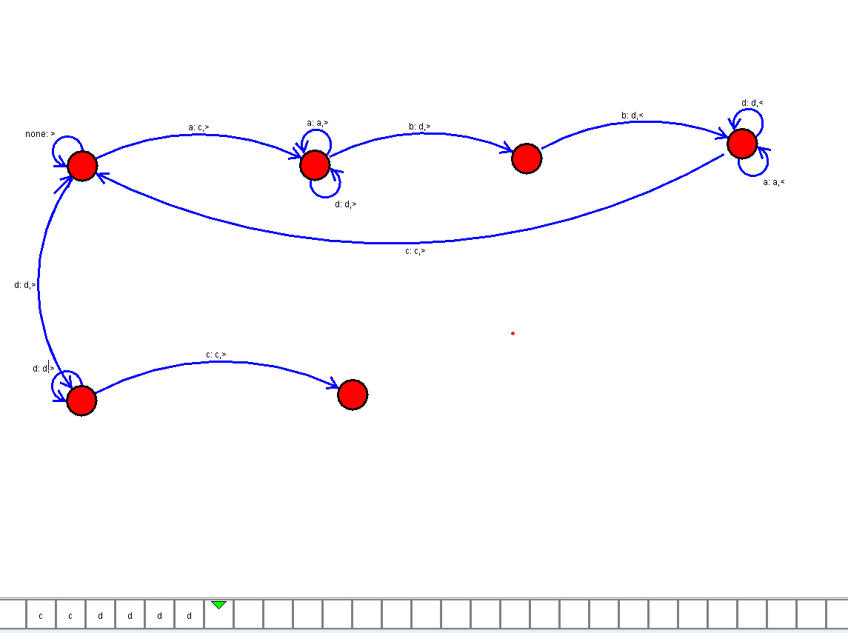

Result:

Successfully executed Turing Machine using simulator over the set {a,b} to accept the input string anb2n